**Analysis of Hotel Room Pricing In The Indian Market**

**BRIEF PROJECT DESCRIPTION**

**The purpose of this project is to analyse the pricing strategy of hotels in the Indian hotel industry.**

**Many factors drive hotel room prices. The objective of this project is to identify the factors that matter the most. Think about the following problem:**

**Room Rent = FUNCTION ( Date(s); Hotel Features; External Factors)**

**HYPOTHESIS 1:**

Hotel room price should significantly depend on external factors i.e hotel’s location as well as internal factors i.e hotel’s features.

**HYPOTHESIS 2:**

Room price of hotel in Tourist destination should be higher.

**HYPOTHESIS 3:**

Room price of hotel having internal features such as swimming pool, free one time breakfast, free wifi and having higher star rating should be more.

**MODEL:**

In order to test these hypothesis I proposed the following model:

model1 <- lm(RoomRent ~ StarRating + IsTouristDestination + IsNewYearEve + FreeWifi + FreeBreakfast + HasSwimmingPool + Airport + IsMetroCity,data = cities)

If there is *,**or *** it means our independent variable is significant. More is the value of coefficient of independent variable more will be it significant and important. A positive value of coefficient indicates that dependent variable increases with increase in the corresponding independent variable.

**RESULT:**

All the three hypothesis were supported by the model.

1) Room price significantly depended upon external factors(IsTouristDestination,distance from airport,IsMetroCity, IsNewYearEve) as well as internal factors(StarRating,FreeWifi,HasSwimmingPool, FreeBreakfast)

> summary(model1)  
  
Call:  
lm(formula = RoomRent ~ StarRating + IsTouristDestination + IsNewYearEve +   
 FreeWifi + FreeBreakfast + HasSwimmingPool + Airport + IsMetroCity,   
 data = cities)  
  
Residuals:  
 Min 1Q Median 3Q Max   
-10452 -2361 -711 984 310352   
  
Coefficients:  
 Estimate Std. Error t value Pr(>|t|)   
(Intercept) -7782.035 393.257 -19.789 < 2e-16 ***  
StarRating 3014.683 98.265 30.679 < 2e-16 ***  
IsTouristDestination 2332.651 133.343 17.494 < 2e-16 ***  
IsNewYearEve 845.669 174.794 4.838 1.33e-06 ***  
FreeWifi 561.683 224.983 2.497 0.0126 *   
FreeBreakfast 310.458 123.248 2.519 0.0118 *   
HasSwimmingPool 1874.913 156.569 11.975 < 2e-16 ***  
Airport 11.303 2.721 4.153 3.30e-05 ***  
IsMetroCity -1868.073 135.855 -13.751 < 2e-16 ***  
---  
Signif. codes: 0 ‘***’ 0.001 ‘**’ 0.01 ‘*’ 0.05 ‘.’ 0.1 ‘ ’ 1  
  
Residual standard error: 6636 on 13223 degrees of freedom  
Multiple R-squared: 0.1816, Adjusted R-squared: 0.1812   
F-statistic: 366.9 on 8 and 13223 DF, p-value: < 2.2e-16

2) Room price of hotel situated in tourist destination was higher as can be senn from below boxplot.

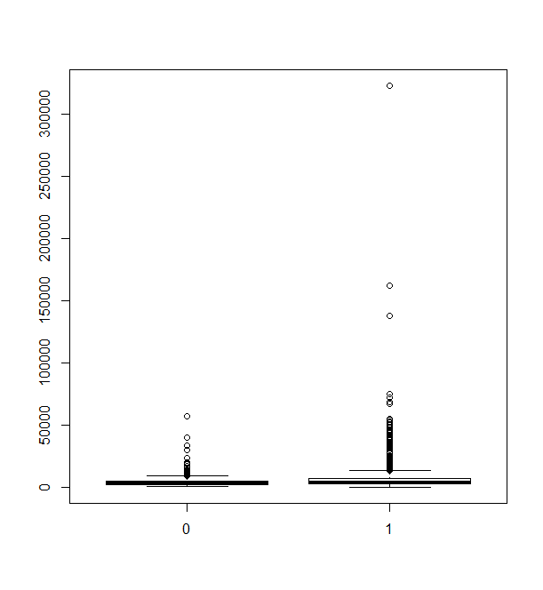

3) Room price of hotel having internal features such as swimming pool, free one time breakfast, free wifi and having higher star rating came out to be higher.

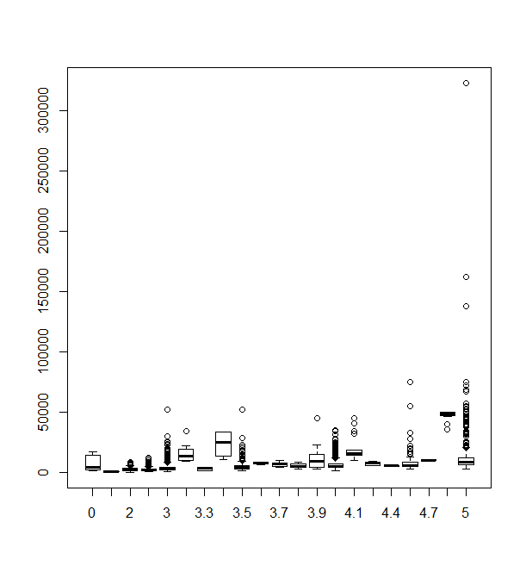

Shown above is box plot of room rent vs star rating of hotel. It can be seen that median value of room rent increases with increase in rating.

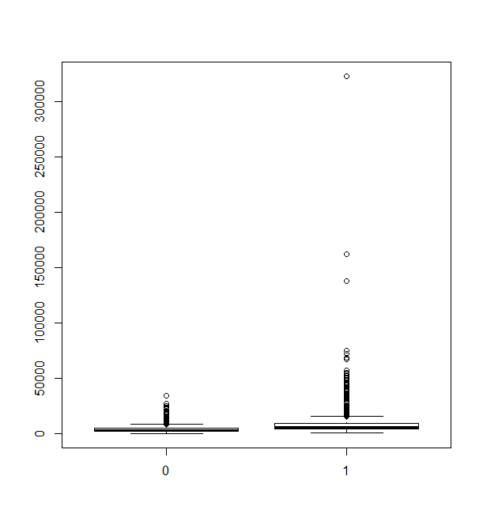

Shown above boxplot of room rent vs hotel having swimming pool. It can be seen that median value of room rent having swimming pool is higher. 1 denotes hotel having swimming pool and 0 denotes hotel not having swimming pool.